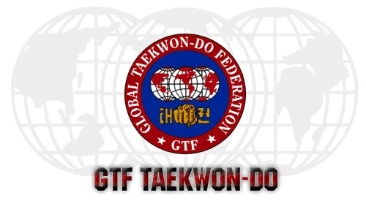

E-mail : johnsonkong1957@gmail.com

GTF INTERNATIONAL INSTRUCTOR SEMINAR 2007

Registration Form
- Please fill in ALL particulars in BLOCK CAPITALS

Name*: ______________________________________________________________
(*to be appeared in the Certificate)
Address : ______________________________________________________________
______________________________________________________________
NRIC/Passport No : _______________________ Sex : __Male _/ __Female__
Employment Pass No : _______________________ Age : ____________________
Nationality : _______________________ Marital Status : ____________________
Telephone : _______________________ Occupation : ____________________
Mobile No : _______________________ Date of Birth : ____________________
E-Mail Address : ______________________________________________________________
Medical History
(Please state if any) : ______________________________________________________________

Name of Dojang/Club : ______________________________________________________________
Name of Chief Instructor : ______________________________________________________________
Present Rank: _____________ (Degree) Certificate No. and issued by_______________________________

Signature :______________________________ Date : ___________________

 | Overseas Participants Seminar’s fees | USD200.00
Fees Paid on or Before 31st May, 2007 | Food & Hotel Accommodations  (4 days 3 nights inclusive breakfast, lunch and dinner). | USD300.00
 | TOTAL: | USD500.00
 | Overseas Participants Seminar’s fees | USD240.00
Fees Paid after 31st May, 2007 | Food & Hotel Accommodations  (4 days 3 nights inclusive breakfast, lunch and dinner). | USD360.00
 | TOTAL: | USD600.00
Note: Please enclose a most recent photograph.

For Hotel Accommodation related matters please contact:-
- Mr. Billy Soon (+6012-3093838) or
- Mr. Chiew Ah Peng (+6012-2005656).

